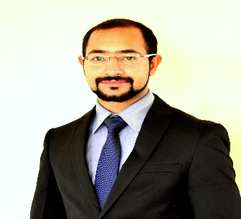

Rahul Sharma
Sr. Sales Solutions Consultant,
Gurucul

I am Rahul Sharma, currently managing the India & SAARC region from technical sales perspective. With over 1.5 decades of extensive experience in the field of cybersecurity, I have had the privilege of contributing to and leading initiatives across global organizations including HCL, Wipro, Zscaler, and currently Gurucul, where I head the SE team for the region.

Holding a Master’s degree in Business Administration, I have a balanced perspective of technology and business strategy. My professional journey has been focused on empowering organizations to strengthen their security posture through innovation, threat intelligence, and proactive defense mechanisms. Having delivered multiple sessions and customer engagements to C-suite and technical audience across the globe, I am passionate about sharing insights on emerging security trends, zero trust architectures, and the evolving landscape of cyber resilience.

I would be honored to contribute and present my perspective on how to make organizations elevate their security posture using industry best practices and with help of AI and Machine Learning to mitigate advance enterprise risks.

Best Regards,
Rahul Sharma,
Sr. Sales Solutions Consultant
Rahul.sharma@gurucul.com

